 | 26.16 Editors - Properties Editor - Texture Properties Tab
Table of content
Detailed table of content 2
Properties Editor - Texture Tab 7
Brush drop down box 7
Texture property 7
New Texture 8
Remove Texture 8
Type 8
Preview panel 8
Blend panel 8
Clouds panel 9
Noise Basis 9
Type 9
Color 9
Size 9
Depth 9
Nabla 9
Distorted Noise panel 10
Noise Basis 10
Distortion 10
Amount 10
Size 10
Nabla 10
Image panel - Settings Subpanel 10
Image Property 11
Source 13
Image panel - Alpha Subpanel 17
Calculate 18
Invert 18
Image panel - Mapping Subpanel 18
Flip Axes 18
Extension 18
Crop subpanel 19
Image panel - Sampling Subpanel 19
Interpolation 19
Size 19
Magic panel 19
Depth 19
Turbulence 19
Marble panel 20
Noise Basis 20
Pattern 20
Second basis 20
Type 20
Size 20
Depth 20
Turbulence 20
Nabla 20
Musgrave panel 21
Noise Basis 21
Type 21
Size 21
Nabla 21
Dimension 21
Lacunarity 21
Octaves 22
Intensity 22
Offset 22
Gain 22
Stucci panel 22
Noise Basis 22
Pattern 22
Type 23
Size 23
Turbulence 23
Voronoi panel 23
Distance Metric 23
Coloring 23
Feature Weights subpanel 23
Wood panel 24
Noise Basis 24
Pattern 24
Second basis 24
Type 24
Turbulence 24
Nabla 24
Colors Panel 25
Clamp 25
Multiply R G B 25
Brightness 25
Contrast 25
Saturation 25
Color ramp subpanel 25
Custom Properties Panel 27
Add 27
Edit 27
Remove 27

Detailed table of content

Detailed table of content
Detailed table of content 2
Properties Editor - Texture Tab 7
Brush drop down box 7
Texture property 7
Texture browser 7
Edit Box 7
Number of users 7
Fake User 7
New Texture 8
Remove Texture 8
Type 8
Preview panel 8
Blend panel 8
Progression 8
Orientation 9
Clouds panel 9
Noise Basis 9
Type 9
Color 9
Grayscale 9
Color 9
Size 9
Depth 9
Nabla 9
Distorted Noise panel 10
Noise Basis 10
Distortion 10
Amount 10
Size 10
Nabla 10
Image panel - Settings Subpanel 10
Image Property 11
Texture browser 11
Edit Box 11
Unlink Data-Block 11
File selector menu 11
New 11
Name 11
Width 11
Height 11
Color 12
Alpha 12
Generated Type 12
32 Bit Float 12
Duplicate 12
Unlink Datablock 12
Fake User 12
Open Image 12
Unpack 12
User 12
Source 13
Source Type Generated 13
X / Y 13
Float Buffer 13
Generated Type Blank 13
Color 13
Generated Type UV Grid 13
Generated Type Color Grid 13
Color Space 14
View as Render 14
Source Type Movie + Image Sequence 14
Path edit box 14
Pack 14
Path edit box 14
Open 14
Refresh 15
Info string 15
Frames 15
Start 15
Offset 15
Cyclic 15
Auto Refresh 15
Deinterlace 15
Color Space 15
View as Render 16
Source Type Single Image 16
Path edit box 16
Pack 16
Path edit box 16
Open 16
Refresh 16
Info string 16
Color Space 17
Alpha 17
View as Render 17
Seam Margin 17
Source Type Udim 17
Image panel - Alpha Subpanel 17
Calculate 18
Invert 18
Image panel - Mapping Subpanel 18
Flip Axes 18
Extension 18
Extend 18
Clip 18
Clip Cube 18
Repeat 18
Repeat X / Y 18
Mirror X / Y 19
Checker 19
Distance 19
Tiles Even / Odd 19
Crop subpanel 19
Crop Minimum X / Y + Crop Maximum X / Y 19
Image panel - Sampling Subpanel 19
Interpolation 19
Size 19
Magic panel 19
Depth 19
Turbulence 19
Marble panel 20
Noise Basis 20
Pattern 20
Second basis 20
Type 20
Size 20
Depth 20
Turbulence 20
Nabla 20
Musgrave panel 21
Noise Basis 21
Type 21
Size 21
Nabla 21
Dimension 21
Lacunarity 21
Octaves 22
Intensity 22
Offset 22
Gain 22
Stucci panel 22
Noise Basis 22
Pattern 22
Type 23
Size 23
Turbulence 23
Voronoi panel 23
Distance Metric 23
Exponent 23
Coloring 23
Feature Weights subpanel 23
Wood panel 24
Noise Basis 24
Pattern 24
Second basis 24
Type 24
Turbulence 24
Nabla 24
Colors Panel 25
Clamp 25
Multiply R G B 25
Brightness 25
Contrast 25
Saturation 25
Color ramp subpanel 25
+ 25
- 25
Tools menu 25
Flip Color Ramp 25
Distribute Stops from Left 25
Distribute Stops Evenly 26
Eyedropper (pipette icon) E 26
Reset Color Ramp 26
Color Mode 26
RGB 26
HSV/HSL 26
Interpolation 26
Ease 26
Cardinal 26
Linear 26
B-Spline 26
Constant 26
Color Ramp 26
Active Color Stop elements 26
Choose active color stop 27
Pos 27
Color 27
Custom Properties Panel 27
Add 27
Edit 27
Remove 27

Properties Editor - Texture Tab

In this panel you can create or load textures for the brushes in the image painting modes.
Note that with the Workbench renderer you have less options.

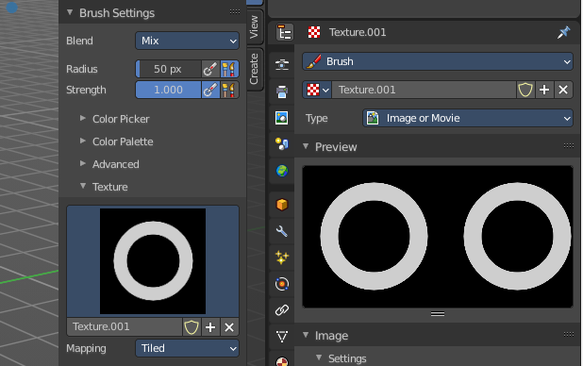
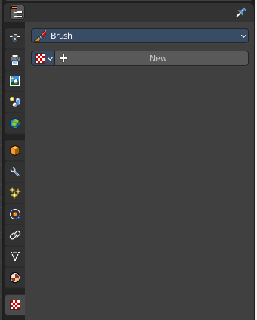

Brush drop down box
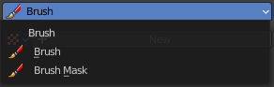
What kind of brush texture you want to create. A brush texture, or a brush mask texture.
Brush textures appears in the texture panel of the brush settings. Brush mask textures appears in the texture mask panel of the brush settings.

Texture property

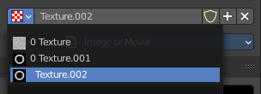
Texture browser
A texture browser with the available textures.

Edit Box
The name of the currently active palette. You can also rename the palette here. A click into the edit box makes the name editable.

Number of users
See how many users the palette currently has.

Fake User
Fake User sets the element to have a fake user. Data without a user is normally not saved. But sometimes you want to force the data to be kept even when the data block has no user.

New Texture
Add a new texture

Remove Texture
Removes the texture as the active texture. Note that the texture is still in the list.

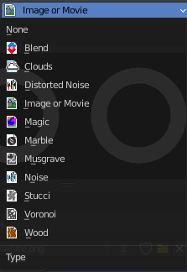
Type
The image type to use. Image or Movie uses pixel based material that you have to load externally. The rest are procedural computer generated textures. Some of them are based at different noise algorithms.
Each texture type has its own settings which will be described below.

Preview panel
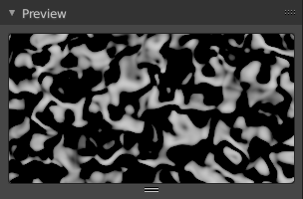
A preview window for the texture.

Blend panel
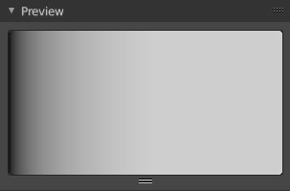
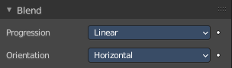
Image Type Blend.

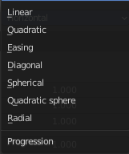
Progression
The style of the color blending.

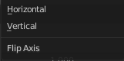
Orientation
The direction. Horizontal or vertical.

Clouds panel

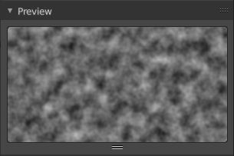
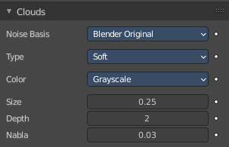
Image type clouds

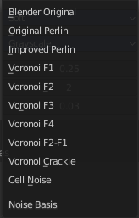
Noise Basis
What noise method to use.

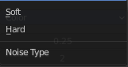
Type
Smooth transitions or sharp transitions. Changes contrast and sharpness.

Color

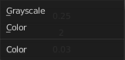
Grayscale
Grayscale based noise. The value returned is greyscale 8 bit.

Color
The noise gives an RGB value. The value returned is rgb 24 bit.

Size
The dimension of the Noise table.

Depth
The depth of the Clouds calculation. A higher number results in a long calculation time, but also in finer details.

Nabla
Size of derivate offset used for calculating normal.
In order to calculate a normal, you usually use three samples in texture space. Typically that's the current sample location, and two other positions in texture U and V directions. This "nabla" value defines how far away these positions are.

Distorted Noise panel

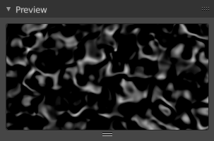
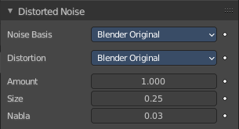
Image type Distorted Noise

Noise Basis
What noise method to use.

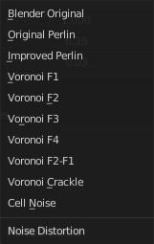
Distortion
What noise method to use for the distortion.

Amount
The amount of distortion.

Size
The dimension of the Noise table.

Nabla
Size of derivate offset used for calculating normal.
In order to calculate a normal, you usually use three samples in texture space. Typically that's the current sample location, and two other positions in texture U and V directions. This "nabla" value defines how far away these positions are.

Image panel - Settings Subpanel

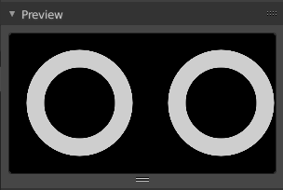
Image type Image or Movie.
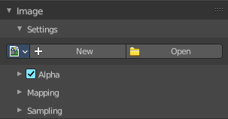

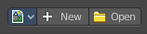
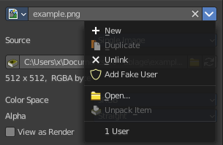
Image Property
Load an image and / or switch to other images.

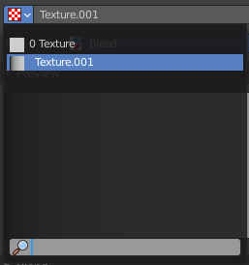
Texture browser
A texture browser with the available textures.

Edit Box
The name of the currently active palette. You can also rename the palette here. A click into the edit box makes the name editable.

Unlink Data-Block
Remove the texture.

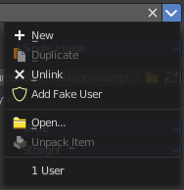
File selector menu

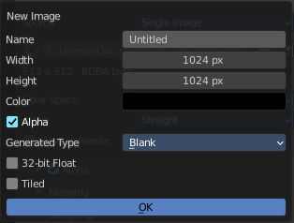
New
Create a new image.
Creates a new image. You will get a dialog where you can define settings for the new image.

Name
The name of the new image

Width
The width of the new image.

Height
The height of the new image.

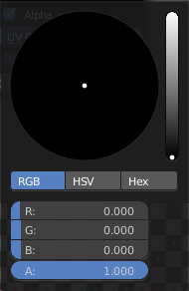
Color
Adjust the color of the new image. A click will call a color picker.

Alpha
Check this checkbox if the new image should have an alpha channel.

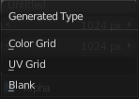
Generated Type
Here you can define what kind of texture you want to create.
Blank is one plain color.
UV Grid is a checker texture in black and white.
Color Grid is a colored checker texture.

32 Bit Float
Check this checkbox if the image should be in 32 Bit floating point bit depth per channel. Else it is in 8 bit per channel.

Duplicate
Not supported here.

Unlink Datablock
This deletes the selected image. Unfortunately not immediately. You need to save the scene and to reload it.
And you need to make sure that it is not linked to anything else. A mesh or a fake user for example. Have a look if there is a number besides the F button. When this is the case then the image has still a user, and so still loads with loading the scene.

Fake User
Wit this button you assign a fake user to this selected image.
Data, like images, that is not longer linked to anything else gets removed when you save and reload a scene. Bforartists has the concept of fake users to go around this behavior. An image with a fake user is in fact linked to something. And so it is not lost when you save and reload the scene.

Open Image
Opens the file browser to load an image.

Unpack
Unpack packed files to a directory.

User
The number of users that uses this data. Data with a user number of 0 will be removed with closing Bforartists.

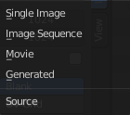
Source
Choose the image type. This type gets usually automatically set. When you create a new image, then this image is generated. When you load an image then the Source switches to Single Image.
Generated images does not have a path.

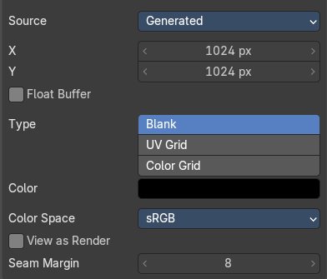
Source Type Generated

X / Y
The image width and height.

Float Buffer
Use a floating point buffer. 8 Bit images uses integers. 32 Bit works with floats.


Generated Type Blank
This type displays an image with one blank color

Color
The color of the blank image.


Generated Type UV Grid
This type displays a with a black and white checker texture but colored dots.


Generated Type Color Grid
This type displays a with a colored checker texture with numbers.


Color Space
Choose the color space type for the image.

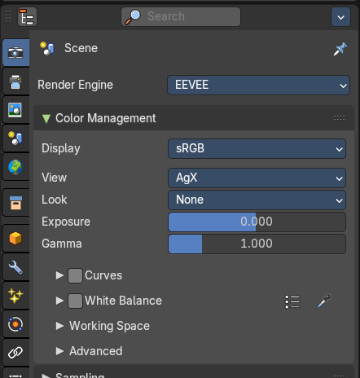
View as Render
Displays the image with the color management settings from the render tab.

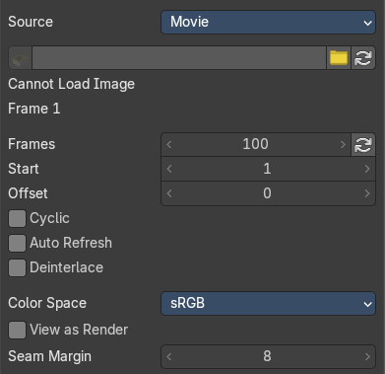
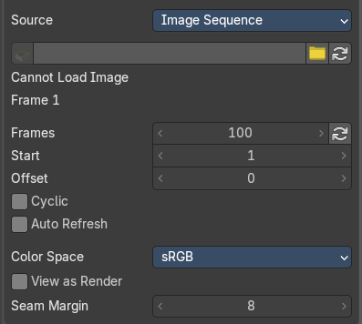
Source Type Movie + Image Sequence


Path edit box

Pack
With this button you can pack the movie or the image sequence into the blend file. It gets packed when you
save the blend file the next time.

Path edit box
See and edit the path to your movie or image sequence files.

Open
Open a new movie or image sequence files. A file dialog will appear.

Refresh
Reread the movie or image sequence files.

Info string
Some information about the currently loaded movie. Frames, resolution and color space.

Frames
The number of frames of the movie or image sequence.

Start
The start frame of the movie or image sequence

Offset
Offset the number of the frame to use in the animation. -1 means off.

Cyclic
Cycle the images in the movie.

Auto Refresh
Always refresh image on frame changes.

Deinterlace
Movie only. Deinterlace the movie file on load.

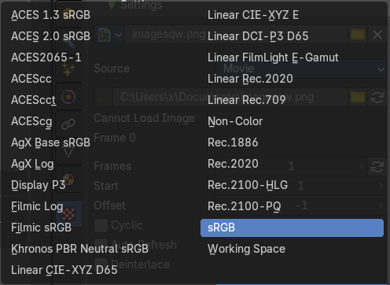
Color Space
Choose the color space type for the movie or image sequence files.

View as Render
Display the image with using the color management settings.

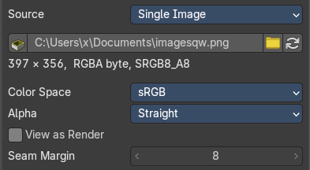
Source Type Single Image

Path edit box

Pack
With this button you can pack the movie or the image sequence into the blend file. It gets packed when you save the blend file the next time.

Path edit box
See and edit the path to your movie or image sequence files.

Open
Open a new movie or image sequence files. A file dialog will appear.

Refresh
Reread the movie or image sequence files.

Info string
Some information about the currently loaded image. Resolution and color space.

Color Space
Choose the color space type for the movie or image sequence files.

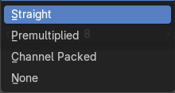
Alpha
Choose the alpha channel mode.

View as Render
Display the image with using the color management settings.

Seam Margin
This option belongs to the UV Editor, and has no effect in the Image editor. Take a margin into account when fixing UV seams during painting.

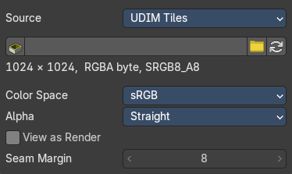
Source Type Udim
UDIM is an enhancement to the UV mapping and texturing workflow. And does not belong here. But in the UV Editor. It is just in the list because it shares the same menus with the UV Editor.

Image panel - Alpha Subpanel
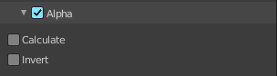
Use the Alpha channel that is stored in the image.

Calculate
Calculate an alpha based on the RGB values of the Image. Black (0, 0, 0) is transparent, white (1, 1, 1) opaque.
Enable this option if the image texture is a mask. Note that mask images can use shades of gray that result in semi-transparency, like ghosts, flames, and smoke/fog.

Invert
Reverses the alpha value. Use this option if the mask image has white where you want it transparent and vice versa.

Image panel - Mapping Subpanel

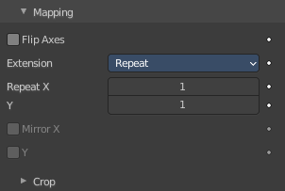
Control how the image is mapped or projected onto the 3D model.

Flip Axes
Rotates the image 90 degrees counterclockwise when rendered.

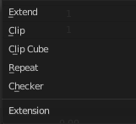
Extension
How the image is extrapolated past the bounds.


Extend
Outside the image the colors of the edges are extended.

Clip
Clip to image size and set exterior pixels as transparent. Outside the image, an alpha value of 0.0 is returned. This allows you to ‘paste’ a small logo on a large object.

Clip Cube
Clips to cubic-shaped area around the images and sets exterior pixels as transparent. The same as Clip, but now the ‘Z’ coordinate is calculated as well. An alpha value of 0.0 is returned outside a cube-shaped area around the image.

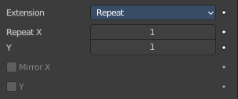
Repeat
The image is repeated horizontally and vertically.

Repeat X / Y
X/Y repetition multiplier.

Mirror X / Y
Mirror on X/Y axes. These buttons allow you to map the texture as a mirror, or automatic flip of the image, in the corresponding X and/or Y direction. They become active when the Repeat value is higher than 1.

Checker
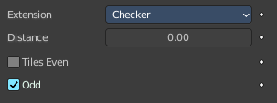
Checkerboards quickly made. You can use the option size on the Mapping panel as well to create the desired number of checkers.

Distance
Governs the distance between the checkers in parts of the texture size.

Tiles Even / Odd
Set even/odd tiles.

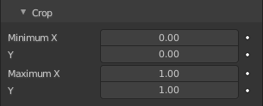
Crop subpanel

Crop Minimum X / Y + Crop Maximum X / Y
The offset and the size of the texture in relation to the texture space. Pixels outside this space are ignored. Use these to crop, or choose a portion of a larger image to use as the texture.

Image panel - Sampling Subpanel

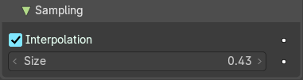
Interpolation
Interpolate pixels using selected filter type.

Size
Multiply the filter size used by interpolation.

Magic panel

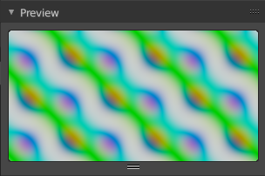
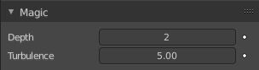
Image type Magic.

Depth
The depth of the calculation. A higher number results in a long calculation time, but also in finer details.

Turbulence
The strength of the pattern.

Marble panel

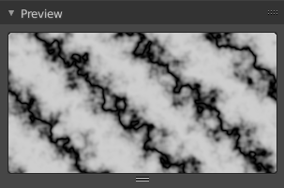
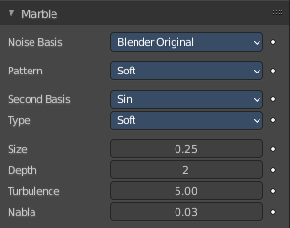
Image type Marble.

Noise Basis
What noise method to use.

Pattern
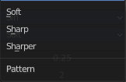
Settings for soft to more clearly defined Marble.

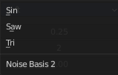
Second basis
Shape of wave to produce bands.

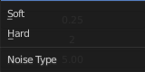
Type
The noise function works with two methods. Soft or hard.

Size
The dimensions of the noise table.

Depth
The depth of the Marble calculation. A higher value results in greater calculation time, but also in finer details.

Turbulence
The turbulence of the sine bands.

Nabla
Size of derivate offset used for calculating normal.
In order to calculate a normal, you usually use three samples in texture space. Typically that's the current sample location, and two other positions in texture U and V directions. This "nabla" value defines how far away these positions are.

Musgrave panel

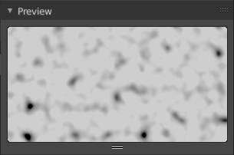
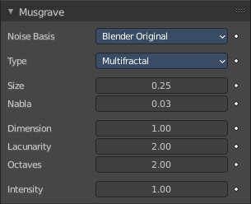
Image type Musgrave.

Noise Basis
What noise method to use.

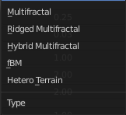
Type
What noise type to use.

Size
The input noise scale.

Nabla
Size of derivate offset used for calculating normal.
In order to calculate a normal, you usually use three samples in texture space. Typically that's the current sample location, and two other positions in texture U and V directions. This "nabla" value defines how far away these positions are.

Dimension
Fractal dimension controls the contrast of a layer relative to the previous layer in the texture. The higher the fractal dimension, the higher the contrast between each layer, and thus the more detail shows in the texture.

Lacunarity
Lacunarity controls the scaling of each layer of the Musgrave texture, meaning that each additional layer will have a scale that is the inverse of the value which shows on the button. i.e. Lacunarity = 2 –> Scale = 1/2 original.

Octaves
Octave controls the number of times the original noise pattern is overlayed on itself and scaled/contrasted with the fractal dimension and lacunarity settings.

Intensity
Light intensity. Called Offset for Hetero Terrain.

Offset
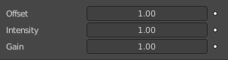
Hybrid Multifractal and Ridged Multifractal type. Both have a “Fractal Offset” button that serves as a “sea level” adjustment and indicates the base height of the resulting bump map. Bump values below this threshold will be returned as zero.

Gain
Hybrid Multifractal and Ridged Multifractal type. Setting which determines the range of values created by the function. The higher the number, the greater the range. This is a fast way to bring out additional details in a texture where extremes are normally clipped off.

Stucci panel

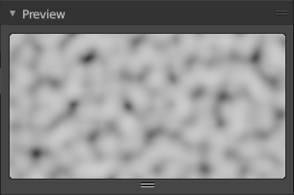
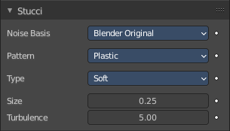
Image type Stucci.

Noise Basis
What noise method to use.

Pattern
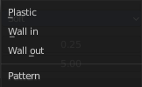
Plastic is the standard Stucci, while the “walls” is where Stucci gets it name. This is a typical wall structure with holes or bumps.

Type
There are two methods available for working with Noise. Soft or Hard.

Size
Dimension of the Noise table.

Turbulence
Depth of the Stucci calculations.

Voronoi panel

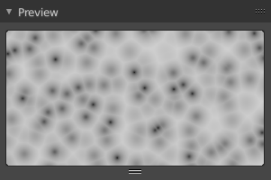
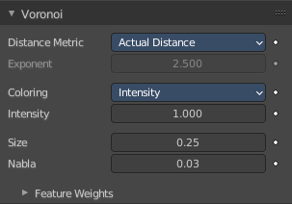
Image type Voronoi.

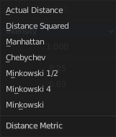
Distance Metric
This procedural texture has seven Distance Metric options. These determine the algorithm to find the distance between cells of the texture.

Exponent
The Minkowski setting has a user definable value (the Exponent button) which determines the Minkowski exponent e of the distance function.
(xe + ye + ze)1/e
A value of one produces the Manhattan distance metric, a value less than one produces stars (at 0.5, it gives a Minkowski 1/2), and higher values produce square cells (at 4.0, it gives a Minkowski 4, at 10.0, a Chebychev). So nearly all Distance Settings are basically the same – a variation of Minkowski.

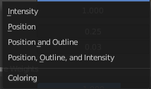
Coloring
Different ways to calculate color and intensity of the texture output.

Feature Weights subpanel
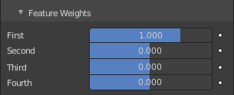
These four sliders at the bottom of the Voronoi panel represent the values of the four Worley constants, which are used to calculate the distances between each cell in the texture based on the distance metric.

Wood panel

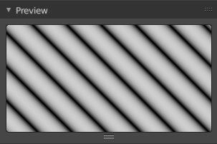
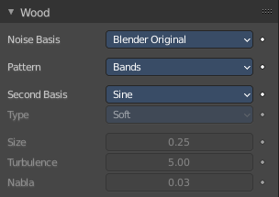
Image type Wood.

Noise Basis
What noise method to use.

Pattern
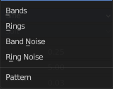
The wood pattern.
Type, Size Turbulence and Nabla are just active with Pattern Type Band Noise and Ring Noise.

Second basis
Shape of wave to produce bands.

Type
Smooth transitions or sharp transitions. Changes contrast and sharpness.

Turbulence
The turbulence of band noise and ring noise.

Nabla
Size of derivate offset used for calculating normal.
In order to calculate a normal, you usually use three samples in texture space. Typically that's the current sample location, and two other positions in texture U and V directions. This "nabla" value defines how far away these positions are.

Colors Panel
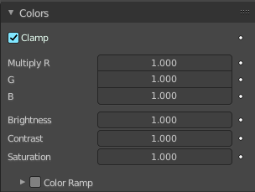

Clamp
Clamps the range by setting the negative rgb and intensity values to zero.

Multiply R G B
Multiply factor for the r g and b channel.

Brightness
The brightness of the texture.

Contrast
The contrast of the texture.

Saturation
The saturation of the texture.

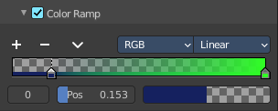
Color ramp subpanel
Specify a range of colors based on color stops. The color between the color stops gets interpolated.

+
Add a stop to your color ramp. The stop will be added after the selected one, in the middle to the next one.

-
Deletes the selected color stop from the list.


Tools menu

Flip Color Ramp
Flips the gradient, inverting the values of the color ramp.

Distribute Stops from Left
Rearrange the stops so that every step has the same space to the right.

Distribute Stops Evenly
Space between all neighboring stops becomes equal.

Eyedropper (pipette icon) E
An Eyedropper to sample a color or gradient from the interface to be used in the color ramp.

Reset Color Ramp
Resets the color ramp to its default state.


Color Mode

RGB
Blends color by mixing each color channel and combining.

HSV/HSL
Blends colors by first converting to HSV or HSL, mixing, then combining again. This has the advantage of maintaining saturation between different hues, where RGB would de-saturate, this allows for a richer gradient.


Interpolation

Ease
Uses an Ease Interpolation for the color stops.

Cardinal
Uses a Cardinal Interpolation for the color stops.

Linear
Uses a Linear Interpolation for the color stops.

B-Spline
Uses a B-Spline Interpolation for the color stops.

Constant
Uses a Constant Interpolation for the color stops.

Color Ramp
The color band. A click at one of the color stops makes it the active one. You can move the color stops by clicking at them and dragging them around.

Active Color Stop elements
Adjust the active color stop.

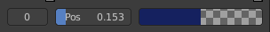
Choose active color stop
Choose the color stop by index.

Pos
The position of the active color stop. The range goes from 0.000 to 1.000

Color
The color of the active color stop. Clicking at it opens a color picker.

Custom Properties Panel


Allows to define custom properties that can be used for scripting.

Here you might also find custom properties from addons or scripts.

Add
Adds a new property.


Edit
Opens a panel where you can adjust the settings for the custom property.

Remove
Removes the property.

